Chapter 8, Problem 64.

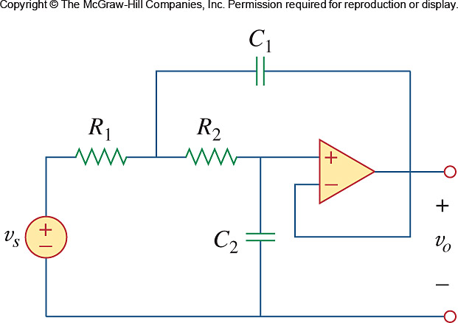
Using Fig. 8.109, design a problem to help other students better understand second-order op amp circuits.

Figure 8.109
For Prob. 8.64.

